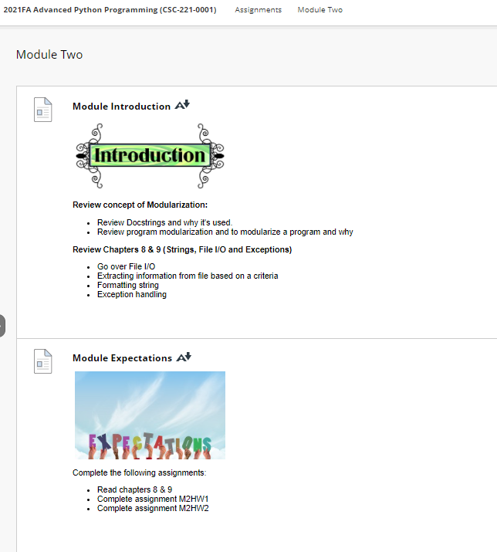

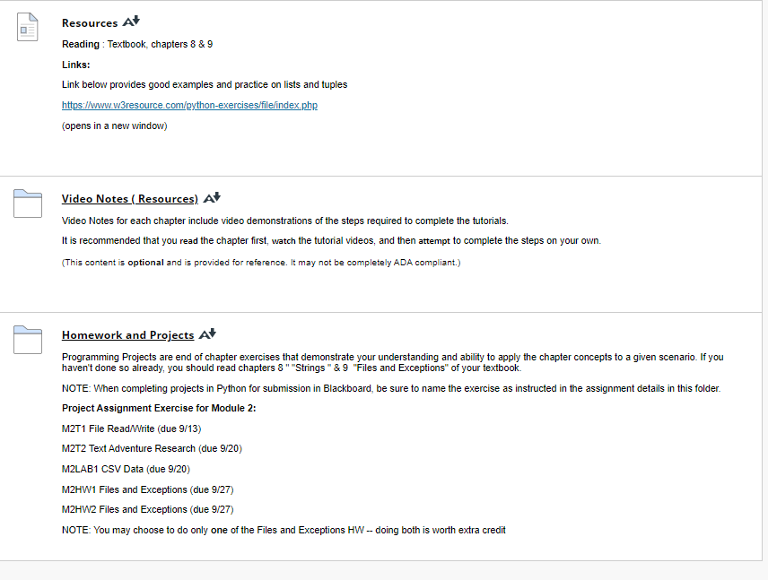

**Resources**

[Resources](https://faytechcc.blackboard.com/webapps/blackboard/content/listContent.jsp?course_id=_35059_1&content_id=_5950090_1)

**Reading** : Textbook, chapters 8 & 9

**Links:**

Link below provides good examples and practice on lists and tuples

<https://www.w3resource.com/python-exercises/file/index.php>

(opens in a new window)

[**Video Notes ( Resources)**](https://faytechcc.blackboard.com/webapps/blackboard/content/listContent.jsp?course_id=_35059_1&content_id=_5950094_1)

[Video Notes ( Resources)](https://faytechcc.blackboard.com/webapps/blackboard/content/listContent.jsp?course_id=_35059_1&content_id=_5950090_1)

Video Notes for each chapter include video demonstrations of the steps required to complete the tutorials.

It is recommended that you **read** the chapter first, **watch** the tutorial videos, and then **attempt** to complete the steps on your own.

(This content is **optional** and is provided for reference. It may not be completely ADA compliant.)

**Video Note : Writing text to a file ( creating a .txt file)**

[Video Note : Writing text to a file ( creating a .txt file)](https://faytechcc.blackboard.com/webapps/blackboard/content/listContent.jsp?course_id=_35059_1&content_id=_5950094_1)

<https://mediaplayer.pearsoncmg.com/assets/STLdHoTa072adtoEIEEh9DAZgprDP6BX>

[Writing to a .txt file](https://mediaplayer.pearsoncmg.com/assets/STLdHoTa072adtoEIEEh9DAZgprDP6BX)  
A video tutorial explains methods of **Writing to a file** , from  *Deitel & Deitel , Intro to Python*.

(This video is **optional** and is provided for reference. It may not be completely ADA compliant.)

### Video Note : Reading from a txt file

<https://mediaplayer.pearsoncmg.com/assets/iGeRsJqec9uQMWhMf97gvon_dH_ZiSe_>

A video tutorial **Reading from a .txt file** of *Deitel & Deitel , Intro to Python* explains how to import modules, use functions and preview list of functions in a module.

(This video is **optional** and is provided for reference. It may not be completely ADA compliant.)

**Video Note : Handling Exceptions**

<https://mediaplayer.pearsoncmg.com/assets/S_wU3UOghVQ1va1HZ9B_6WnbZRFp0O72>

[Handling Exceptions](https://mediaplayer.pearsoncmg.com/assets/S_wU3UOghVQ1va1HZ9B_6WnbZRFp0O72)  
A video tutorial explains methods of  **Handling Exceptions** of *Deitel & Deitel , Intro to Python*.

(This video is **optional** and is provided for reference. It may not be completely ADA compliant.)

**Video Note : Pandas to read csv files to a program**

[Video Note : Pandas to read csv files to a program](https://faytechcc.blackboard.com/webapps/blackboard/content/listContent.jsp?course_id=_35059_1&content_id=_5950094_1)

<https://mediaplayer.pearsoncmg.com/assets/ZygtyOtUk1CIoD9x7pBvn7GHJ6uOI5EW>

A video tutorial explains **Using Pandas to read CSV files** . From *Deitel & Deitel , Intro to Python*.

(This video is **optional** and is provided for reference. It may not be completely ADA compliant.)